PRESENTATION AT HARVARD CONFERENCE: DESIGN FOR URBAN DISASTERS: PREVENTION AND RESPONSE
Graduate School of Design

“HAS THE TIME COME TO SERIOUSLY CONSIDER DRONES IN RECOVERY?”

The panel focused on the inevitability of using Unmanned Aerial Vehicles (UAVs) in disaster responses. The benefits seem to clearly outweigh concerns, and in a disaster situation UAVs could be overwhelmingly beneficial.
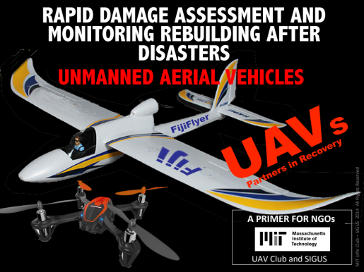

The panel was moderated by Dr. Reinhard Goethert, MIT. Panelists included re a representative from an NGO with experience in Haiti, Dave Hampton, Principal, re:ground LLC, and members of the MIT UAV club involved in the research: Jacob Shearman, Sam Udotong, Sinead Cheung, Yamile Pariented. Staff form the Aurora Flight Company (a company located in Cambridge that designs and manufactures UAVs.) were unable to attend at the last minute.
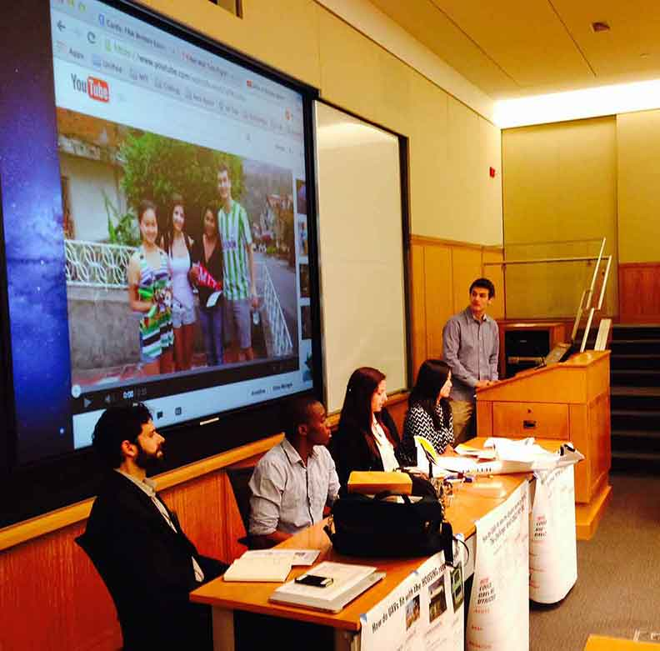

A range of examples of UAVs were on display, and briefly flown to demonstrate

The panel explored several basic issues:

Are UAVs now sufficiently developed and commonly available to consider their use, from a technical and cost perspective (brief presentation of the range of available off-the-shelf UAVs)?
What are probable benefits in the use of UAVs (summation and discussion of how UAVs could assist, in assessing damage and monitoring rebuilding; overview of how UAVs are already being used in other sectors)?
What are the major hurdles to the use of UAVs (summation of mainly regulatory concerns of privacy and safety)?
What is required for NGOs to adopt UAVs in their recovery operations (discussion of how to overcome regulatory impasse and how NGOs would need to adapt to UAVs)?

Several charts were presented to challenge the audience:


